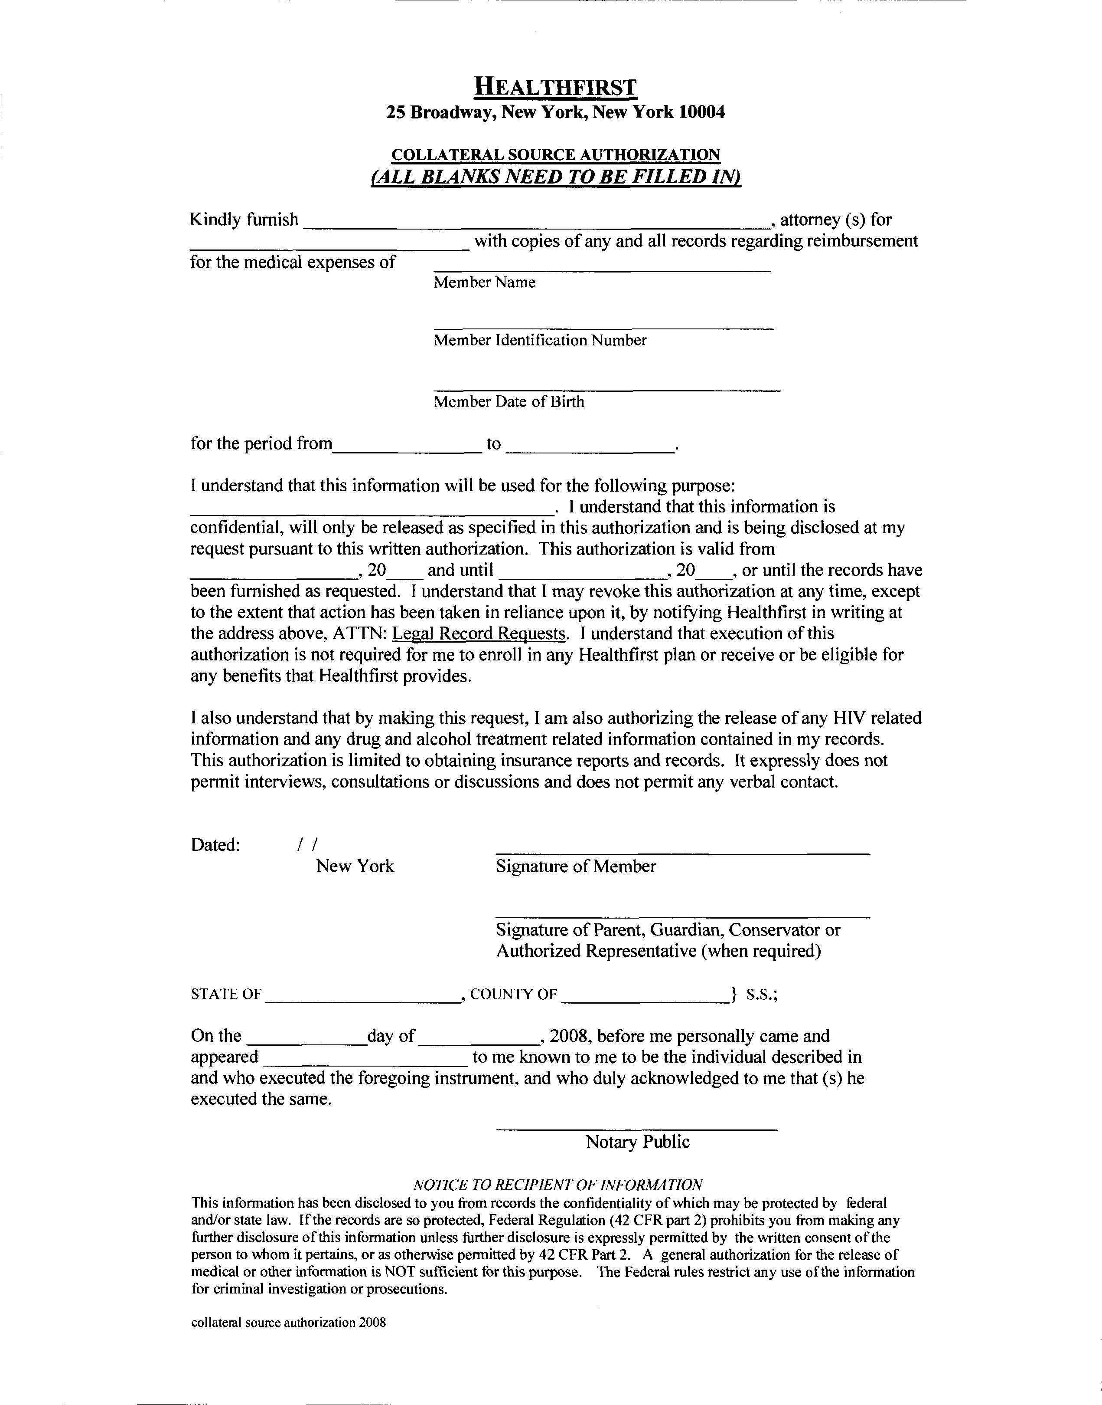
Order No. 01-24351 - 003
Elodia Ayler-Jordan

Axiom Requisition Copy Service, as agent of Mary T. Doll, The Hanover Law Group
03/29/1947
Janet Presta
Litigation
Present
03/29/1947

